- Implement a K-Nearest Neighbors (KNN) classifier in Python to predict whether a Flipkart product review is 'positive' or 'negative' using a small dataset of review texts and their labels. Use scikit-learn's KNeighborsClassifier and convert the text data into numerical features using CountVectorizer.
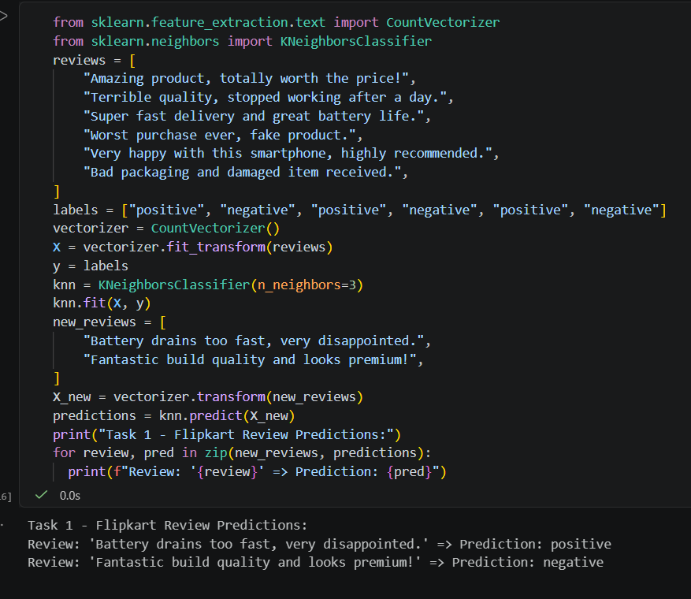

- Compare the accuracy of KNN using Euclidean distance vs. Manhattan distance on a dataset of Spotify song features (e.g., tempo, danceability, energy) to classify songs as 'workout' or 'chill' playlists.Use the 'metric' parameter in KNeighborsClassifier to switch between 'euclidean' and 'manhattan'.

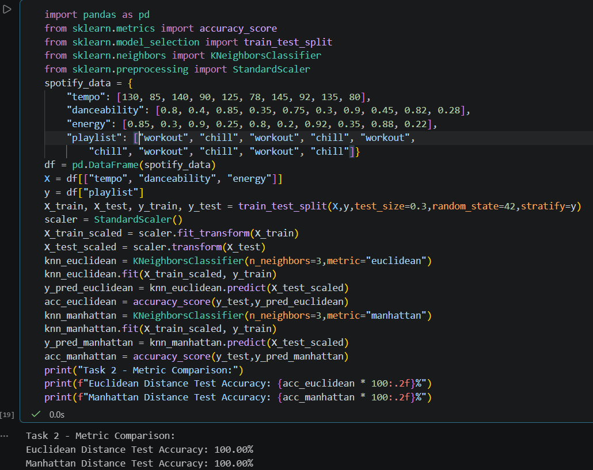

- Use Gaussian Naive Bayes to classify whether an IRCTC train booking is likely to be 'confirmed' or 'waitlisted' based on features like booking time, train popularity, and travel day (use a small mock dataset).
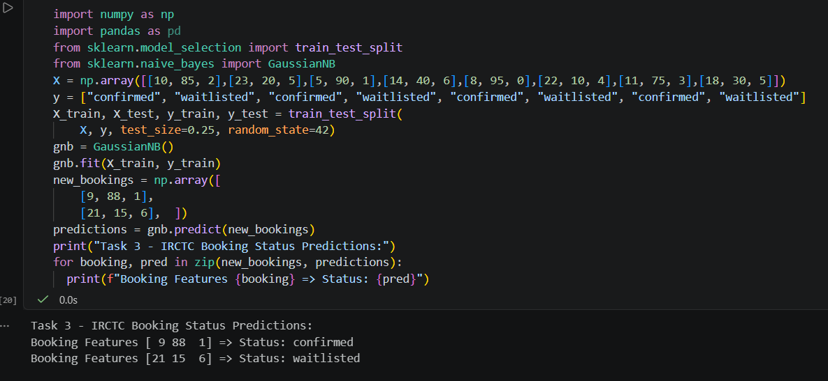

- Build a Multinomial Naive Bayes classifier to categorize WhatsApp chat messages as 'personal', 'group', or 'spam' using example message texts and labels. Use scikit-learn's MultinomialNB and show the confusion matrix for your results.
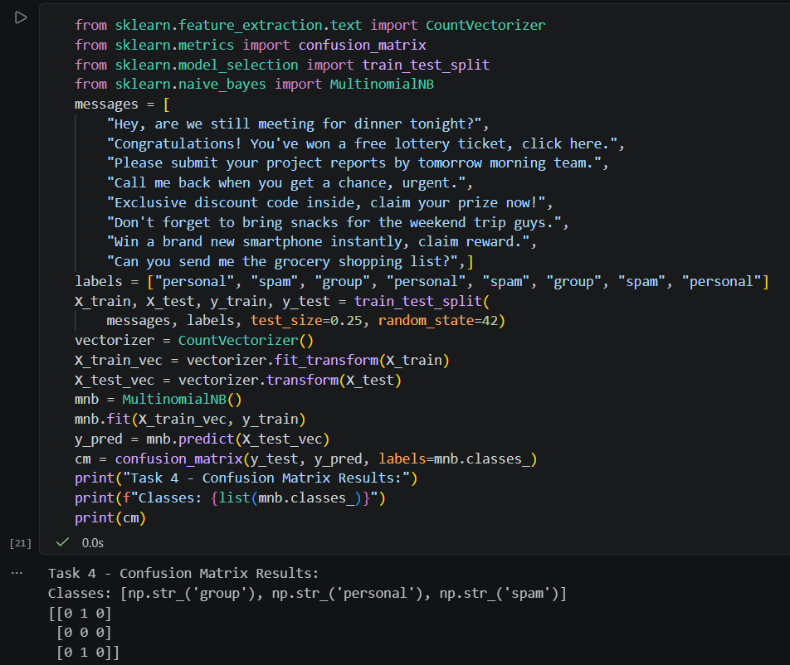

- Use ChatGPT or Copilot to generate Python code for a KNN-based image classifier that distinguishes between images of cricket bats and footballs (use any small sample image dataset or random pixel arrays), then run and test the code, noting any changes you made to get it working. Paste the AI-generated code, describe any errors, and how you fixed them.

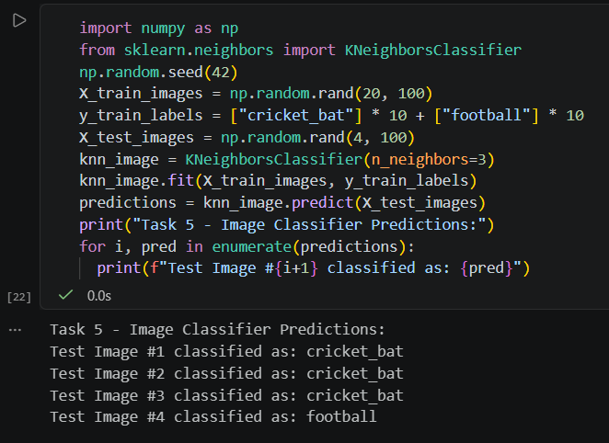

Fixes & Adjustments made during testing: Real image files require preprocessing modules like PIL or OpenCV (cv2) to load files, resize dimensions uniformly, and flatten matrices. Using np.random.rand allows verifying the pipeline logic directly without needing external image path dependencies.

